### EMAIL ETIQUETTE

### One of the most extraordinary things that emerged during the era of globalization in the field of communication chiefly within the organizations is email. Low cost, quick feedback and time saving are some of the factors why emails have become an integral part of in-house correspondence.

### It is a well-known fact that letter writing is orthodox and completely conventional in terms of lay out, structure, content and very formal but email writing is informal, no grammatical rules are implied except a few rudimentary aspects and page layout doesn’t exist.

### Emails also have a few acronyms which are accepted worldwide. Even though emails are solidly established form of communication today, one should know when to send a mail. For instance, if the Manager wants to write a mail on emotionally charged subject to his/her subordinate, it would be better to have a face-to-face conversation than to send an email because speaking directly is the best option here for the manager.

### Style structure and content:

### According to a digital research made by the Radicati Group, more than 294 billion emails are sent and received daily. This rapid usage has resulted in inventions of new jargons in email writing. A new person to this world is utterly bamboozled by the weird punctuation marks which are used in topsy-turvy and different kinds of faces used. These faces (sometimes crying and smiling) are called *smileys.* These are part of bigger class of email tools known as *emoticons.*

**Common Emoticons and Abbreviations**  
Emoticons typically represent a facial expression and are used chiefly to mark the tone of the preceding sentence or to indicate the writer's feelings. The following are some of the more commonly seen:

|  |  |  |  |
| --- | --- | --- | --- |
| **:-)** | happy (a 'smiley') | **:-(** | Unhappy |
| **:-D** | Laughing | **:-||** | angry |
| **;-)** | winking; just kidding | **:-V** | Shouting |
| **:-\*** | Kiss | **|-O** | Yawning |
| **:-o** | Surprised | **:-Q** | I don't understand |
| **:-(** | Frowning | **:-&** | tongue-tied |
| **:-c** | very unhappy | **:-X** | my lips are sealed |
| **X=** | fingers crossed | **:-P** | sticking one's tongue out |
| **:'-(** | Crying | **:-/** | Skeptical |
| **:-|** | bored, indifferent | **:-Y** | aside comment |

**Abbreviations**  
Some of the more established abbreviations used in all types of electronic communication are listed below:

|  |  |  |  |
| --- | --- | --- | --- |
| @ | At | MOB | Mobile |
| AFAIK | as far as I know | MSG | Message |
| AFK | away from the keyboard | MYOB | mind your own business |
| ASL | age, sex, location | NE1 | Anyone |
| ATB | all the best | NOYB | none of your business |
| B | Be | NO1 | no one |
| BAK | back at the keyboard | OTOH | on the other hand |
| BBL | be back late(r) | OIC | oh I see |
| BCNU | be seeing you | PCM | please call me |
| BFN | bye for now | PLS | Please |
| B4 | Before | PPL | People |
| BRB | be right back | R | Are |
| BTW | by the way | ROTF(L) | rolling on the floor (laughing) |
| C | See | RUOK | are you okay? |
| CUL8R | see you later | SIT | stay in touch |
| F2F | face to face | SOM1 | Someone |
| F2T | free to talk | SPK | Speak |
| FWIW | for what it’s worth | TTYL | talk to you later |
| FYI | for your information | TX | Thanks |
| GAL | get a life | U | You |
| GR8 | Great | WAN2 | want to |
| HAND | have a nice day | W/ | With |
| H8 | Hate | WKND | Weekend |
| HSIK | how should I know? | WU | what's up? |
| HTH | hope this helps | X | Kiss |
| IANAL | I am not a lawyer, but - (as a disclaimer) | XLNT | Excellent |
| IMHO | in my humble opinion | XOXOX | hugs and kisses |
| IMO | in my opinion | YMMV | your mileage may vary (i.e. your experience may differ) |
| IOW | in other words | YR | Your |
| JIC | just in case | 2 | to, too |
| JK | just kidding | 2DAY | Today |
| KIT | keep in touch | 2MORO | Tomorrow |
| KWIM | know what I mean | 2NITE | Tonight |
| L8R | Later | 3SUM | Threesome |
| LOL | lots of luck / laughing out loud | 4 | For |

### Email Etiquette:

### There are many books and web information on email etiquette rules. These rules are not universal but one can narrow them down and settle with a few general rules.

### Write a meaningful subject line.

Recipients scan the subject line in order to decide whether to open, forward, file, or trash a message. Remember -- your message is not the only one in your recipient's mailbox.

### Keep the message focused and readable.

Often recipients only read partway through a long message, hit "reply" as soon as they have something to contribute, and forget to keep reading. This is part of human nature.

**Use standard capitalization and spelling,** especially when your message asks your recipient to do work for you.

### Identify yourself clearly.

When contacting someone cold, always include your name, occupation, and any other important identification information in the first few sentences.

### Use proper structure and layout:

### It is better to use paragraphs when we write a mail to make it clear to the recipient.

### Proofread

If you are asking someone else to do work for you, take thetime to **make your message look professional.** While your spell checker won't find every mistake, at the very least it will catch a few typos (typographical error). If you are sending a message that will be read by someone higher up on the chain of command (a superior or professor, for instance), or if you're about to mass-mail dozens or thousands of people, take an extra minute or two before you hit "send". Show a draft to a close associate, in order to see whether it actually makes sense.

### Be concise and to the point:

### An email is mainly used for communicating short messages so; any longer message is quite hard to read because it’s not a printed material. Hence, the mail should always be short.

### Distinguish between formal and informal situations.

When you are writing to a friend or a close colleague, it is OK to use "smilies" :-) , abbreviations (IIRC for "if I recall correctly", LOL for "laughing out loud," etc.) and nonstandard punctuation and spelling (like that found in instant messaging or chat rooms). These linguistic shortcuts are generally signs of friendly intimacy.

**Do not write in capitals:**

Writing in capitals means you are shouting at someone. It leads to unnecessary complications though you are intended to do. Never use caps.

**Sample email template:**

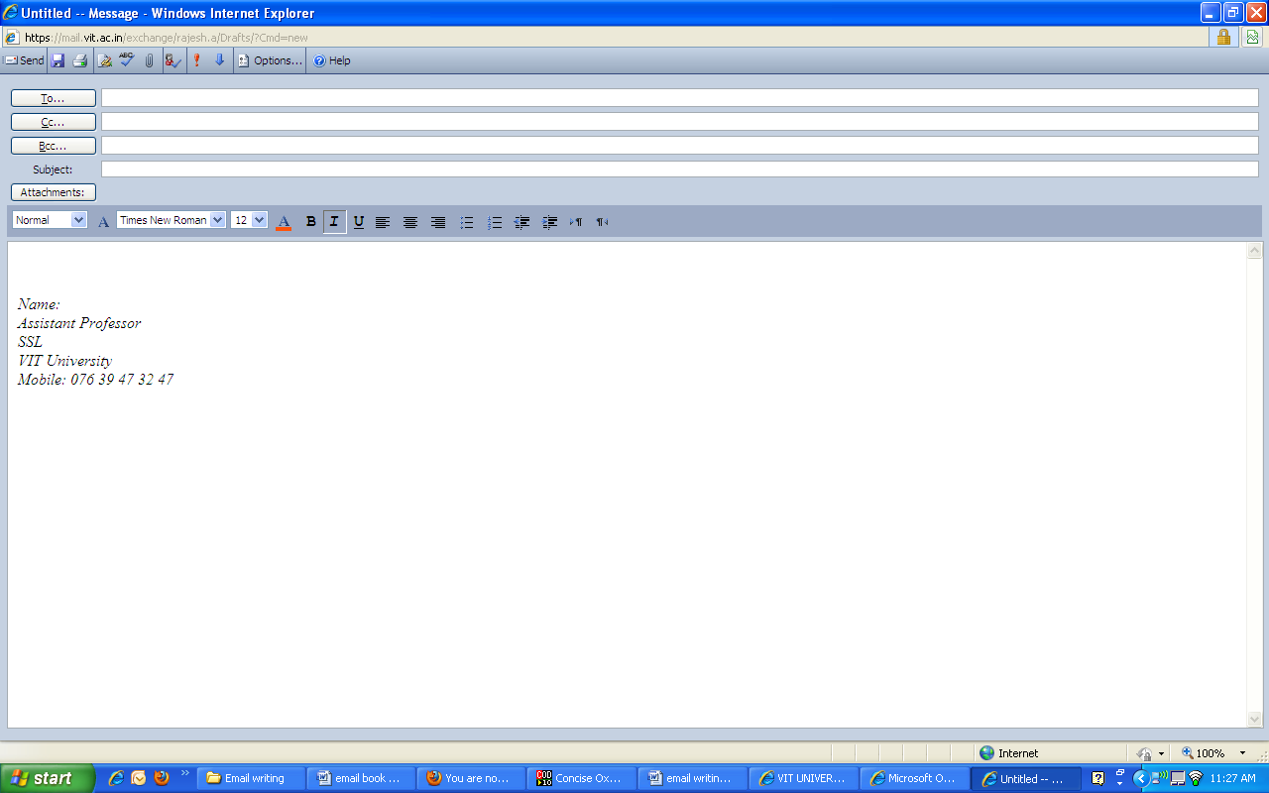

**Sample email:**

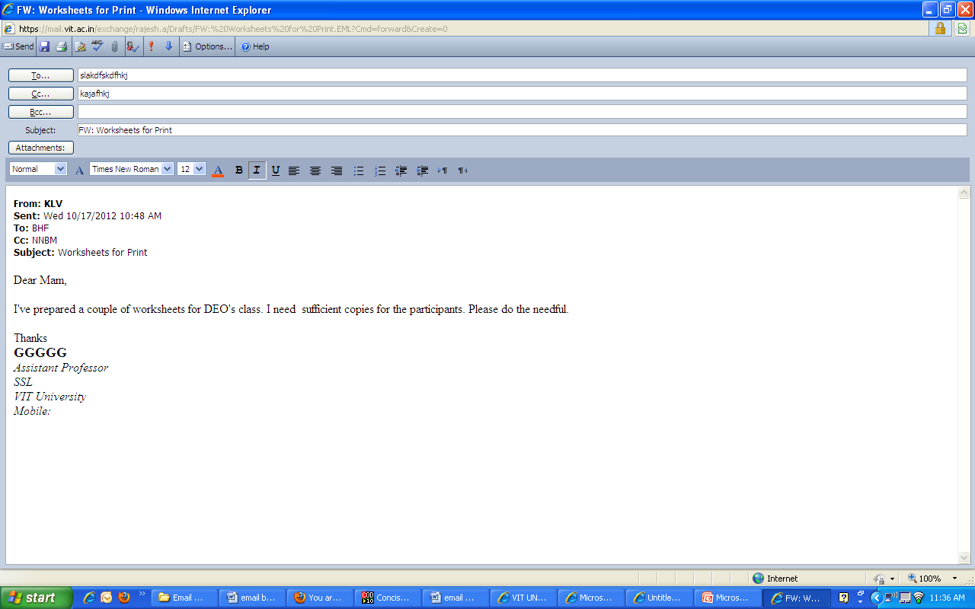

**Sample mail 2:**

**Electric Maintenance - Class/Labs scheduled on Aug. 7, 13-15 - Reg.**

[Director (Academics)](" \o "dean.acad@vit.ac.in)

|  |  |
| --- | --- |
| **To:** | allfaculty |
| **Cc:** | Janfggg A; Registrar; |
| **Attachments:** |  |

Dear Colleagues,

AD (E) has informed that electrical maintenance works are to be undertaken on Aug 7. and 13-15 Aug. 2011.

On 7 Aug. 2011 (Sunday), electric power for lighting will not be available. On 13-15th Aug. 2011 (Saturday – Monday), electricity will not be available to Labs, air conditioners, etc. Though the days are non-instructional days, some of the faculty might have scheduled extra classes/ lab works/ Ph.D/Research works and hence they are informed as above.

With regards,

Director HJY

Phone: 00000000

**Worksheet 1:**

**Email- meetings language, vocabulary and abbreviations**

*In pairs, decide which of the following rules you think would be good to have in your company:*

It is generally best to *CC* your boss into all messages.

Under no circumstances must you send personal emails from work.

Please make a habit of pasting all documents into *the body of the email* as well as attaching them.

Please make sure you report anyone in the office who is *forwarding* joke emails.

We recommend you avoid opening all *attachments.*

You might find it is a good idea to write and *spell check* your emails in Word and then *paste* them into your email later.

It is company policy to be careful with spelling and punctuation even in short, informal emails.

We strongly recommend that you use clear paragraphs (one topic per paragraph).

Try to avoid using short forms and abbreviations (*CU, RU* etc.) in any emails.

The best method of dealing with *junk mail* is to set your protection on ‘high’ and check your *trashcan* for emails that are not junk once every couple of days.

For security and privacy reasons, it is not permitted to copy your work emails onto *flash drives, floppy disks* etc.

Deleting work emails is not allowed.

We suggest keeping all emails short.

As some people who read our emails are not native speakers, you should make an effort to use simple language.

Please try your best to keep all sentences short and avoid complicated forms to understand, like passives.

Please be sparing with the use of *emoticons.*

You might find it better to avoid words in your *subject line* like “money” and “hi”, as these are often used in junk mails and people tend to delete them without reading them.

It is vital that you remember to copy all messages into *the ‘sent’ folder.*

Please make an effort to write interesting subject lines that will get people’s attention.

Ideally, an email should be no more than 5 sentences long.

Without fail, *quote back*. This will ensure that the person you are replying to remembers what you are talking about.

**Worksheet 2:**

**Fill the blanks**

|  |  |
| --- | --- |
| **Opening (informal)**   * Hi! It was great to __________from you! * Thanks for the email you __________. * How are __________? * How’s __________ going? * Hi, what’s __________? | **Closing salutation (informal)**   * Write soon and take __________. * All the __________. * A big __________ from me and my sister. * Lots of __________. * Bye __________ now. |
| **The reason for writing**   * I’m writing to thank you __________ your help. * I’m writing to __________ you __________ my new job. * You asked __________ my help with your boss. So… * Just a quick __________ to arrange a time to meet. * I am writing to enquire __________the Irish Coast Tours. * With __________ to your email asking for information about …. * I am writing to ask for __________ information about the pottery course. | **Expressing your feelings (informal)**   * It __________ me feel so bad when I heard you’d lost your job! * I __________ really good when Annie told me of your wedding! * I was shocked when I __________ out you had resigned. * That’s wonderful __________! I’m so happy for you! * I’m sorry you’re having __________ a hard time at the moment. |
| **Reference to future contact**   * __________ me know if you need anything else. * We’ll __________ about it when you come down to London. * I __________ wait to __________ your next email and find out about your new boyfriend! * It’ll be __________ to see you again next month. * Give me a __________ as soon as you get this email. * Please let me __________ if you have any other similar offers __________.   I __________ __________ to meeting you in June. | **Giving advice** (informal)   * Have you __________ about giving up smoking? * __________ you do, don’t break up with John! * __________ about inviting your in-laws for dinner? * You really __________ do something about your son. * I suggest __________ on a diet as soon as you can. Why __________ you take up yoga? * You’ve __________ __________ break up with him. * If I __________ you I __________ bother so much. |
| **Arranging to meet (informal)**   * __________ Saturday be ok? * Shall me __________ it on Sunday? * __________ after 9 is okay. * Saturday is good __________ me. * __________ __________ Saturday at 9? | * __________ of __________, I will have to contact my lawyer. * I sent you three emails. __________, you have not taken any action yet. * __________ __________ I washed the shirt in cold water it shrunk. |
| **Applying for a job**   * __________ to the advertisement yesterday in ‘The Job Magazine’…. * I am writing to __________ __________ the position of Store Manager as __________ in ‘The Job Magazine’. * I would like to __________ my application for the position of Sales Assistant. * I have been working __________ AGFT Ltd. Since 2003. * I am __________ with most computer programmes. * Please find __________ a copy of my CV for __________ details. * I will be __________ for interview at any time in June. * I am available for interview at short __________. * If you have any questions, please do not __________ to contact me. | **Enquiring/asking for information**   * I was __________ how long you have had your car. * __________ it be __________ to tell me if you sell Italian furniture? * I have __________ __________ if they will like this kind of present. * I would __________ if you could send me this information as soon as possible. * I need to __________ out where the group is meeting. |
| **Linking words**   * __________ I am a keen golf player, I do not have much experience. * __________ __________ all I would like to know where the course will take place. * __________ __________ to this I need to have information about car hire. * What __________ __________, the receptionist was extremely rude to me. | **Complaining**   * …. the quality of the meals did not __________ my expectations. * I feel I am __________ to a __________ of 80% of the amount I paid. * To make __________ worse, they did not listen to me. * I hope that I will not be forced to take __________ action.   I hope the __________ will be __________ by the end of the month. |

**Key**

**Opening (informal)**

Hi! It was great to hear from you!

Thanks for the email you sent.

How are things?

How’s life going?

Hi, what’s up?

**The reason for writing**

I’m writing to thank you for your help.

I’m writing to tell you about my new job.

You asked for my help with your boss. So…

Just a quick note to arrange a time to meet.

I am writing to enquire about the Irish Coast Tours.

With regard to your email asking for information about ….

I am writing to ask for more information about the pottery course.

**Reference to future contact**

Let me know if you need anything else.

We’ll talk about it when you come down to London.

I can’t wait to get your next email and find out about your new boyfriend!

It’ll be great to see you again next month.

Give me a call as soon as you get this email.

Please let me know if you have any other similar offers available.

I look forward to meeting you in June.

**Closing salutation (informal)**

Write soon and take care.

All the best.

A big hug from me and my sister.

Lots of love.

Bye for now.

**Expressing your feelings (informal)**

It made me feel so bad when I heard you’d lost your job!

I felt really good when Annie told me of your wedding!

I was shocked when I found out you had resigned.

That’s wonderful news! I’m so happy for you!

I’m sorry you’re having such a hard time at the moment.

**Giving advice** (informal)

Have you thought about giving up smoking?

Whatever you do, don’t break up with John!

How about inviting your in-laws for dinner?

You really should do something about your son.

I suggest going on a diet as soon as you can.

Why don’t you take up yoga?

You’ve got to break up with him.

If I were you I wouldn’t bother so much.

**Arranging to meet (informal)**

Would Saturday be ok?

Shall me make it on Sunday?

Anytime after 9 is okay.

Saturday is good for me.

How about Saturday at 9?

**Applying for a job**

Further to the advertisement yesterday in ‘The Job Magazine’….

I am writing to apply for the position of Store Manager as advertised in ‘The Job Magazine’.

I would like to submit my application for the position of Sales Assistant.

I have been working for AGFT Ltd. Since 2003.

I am familiar with most computer programmes.

Please find enclosed a copy of my CV for further details.

I will be available for interview at any time in June.

I am available for interview at short notice.

If you have any questions, please do not hesitate to contact me.

**Linking words**

Although I am a keen golf player, I do not have much experience.

First of all I would like to know where the course will take place.

In addition to this I need to have information about car hire.

What is more, the receptionist was extremely rude to me.

Because of this, I will have to contact my lawyer.

I sent you three emails. However, you have not taken any action yet.

Even though I washed the shirt in cold water it shrunk.

**Enquiring/asking for information**

I was wondering how long you have had your car.

Would it be possible to tell me if you sell Italian furniture?

I have no idea if they will like this kind of present.

I would appreciate if you could send me this information as soon as possible.

I need to find out where the group is meeting.

**Complaining**

…. the quality of the meals did not meet my expectations.

I feel I am entitled to a refund of 80% of the amount I paid.

To make matters worse, they did not listen to me.

I hope that I will not be forced to take further action.

I hope the matter will be resolved by the end of the month.

**Worksheet 3:**

**What's Your EQ? (E-Mail Quotient)**

This e-mail contains 10 common errors that weaken the message's effectiveness. How many of these errors can you find?

Add up your correct responses to determine your EQ score.

Subject: FYI   
Date: 30/03/2013 02.00 PM IST  
From: XYS Management   
To: Office Managers, Main Building

Attached file:

On Tuesday, May 23rd, computer equipment was stolen from Global Mailing, a tenant on the 7th floor. (Global Mailing is the company that gives those legendary Christmas parties with the unforgettable rum punch!) Our security camera recorded a man leaving the building. Apparently the thief entered the unlocked suite, placed the computer in a moving crate and loaded it onto a van parked at the rear loading dock. The Boston Police were contacted and a report was filed. The police informed us that there is a man posing as a professional mover who enters offices, steels computers and other office equipment as well as wallets. The tape with the photo of the suspect is available at the guard's desk. Please stop by and take a look. If you recognize this man, have any information regarding this theft, or if you experience a theft in your suite, please contact us, and the Boston Police. Please remember never to leave your reception area unattended and to screen visitors carefully. Remember to keep your suite doors and desks locked. The attached file is our 30 page manual containing information on security procedures. Please familiarize yourself with the relevant material. BTW, the electricity will be shut off at noon today (May 25) and remain off for two hours for maintenance. If using a computer, take appropriate steps so you won't lose data during this power outage. .